1. Error:

Constructer Book(int) should not occur twice, which may not differentiate between *size* and *price*;

Better to set class variables *size,price,name* as Private;

The last method lacks *return* type after public which is String in that case. (Better to change name to getName);

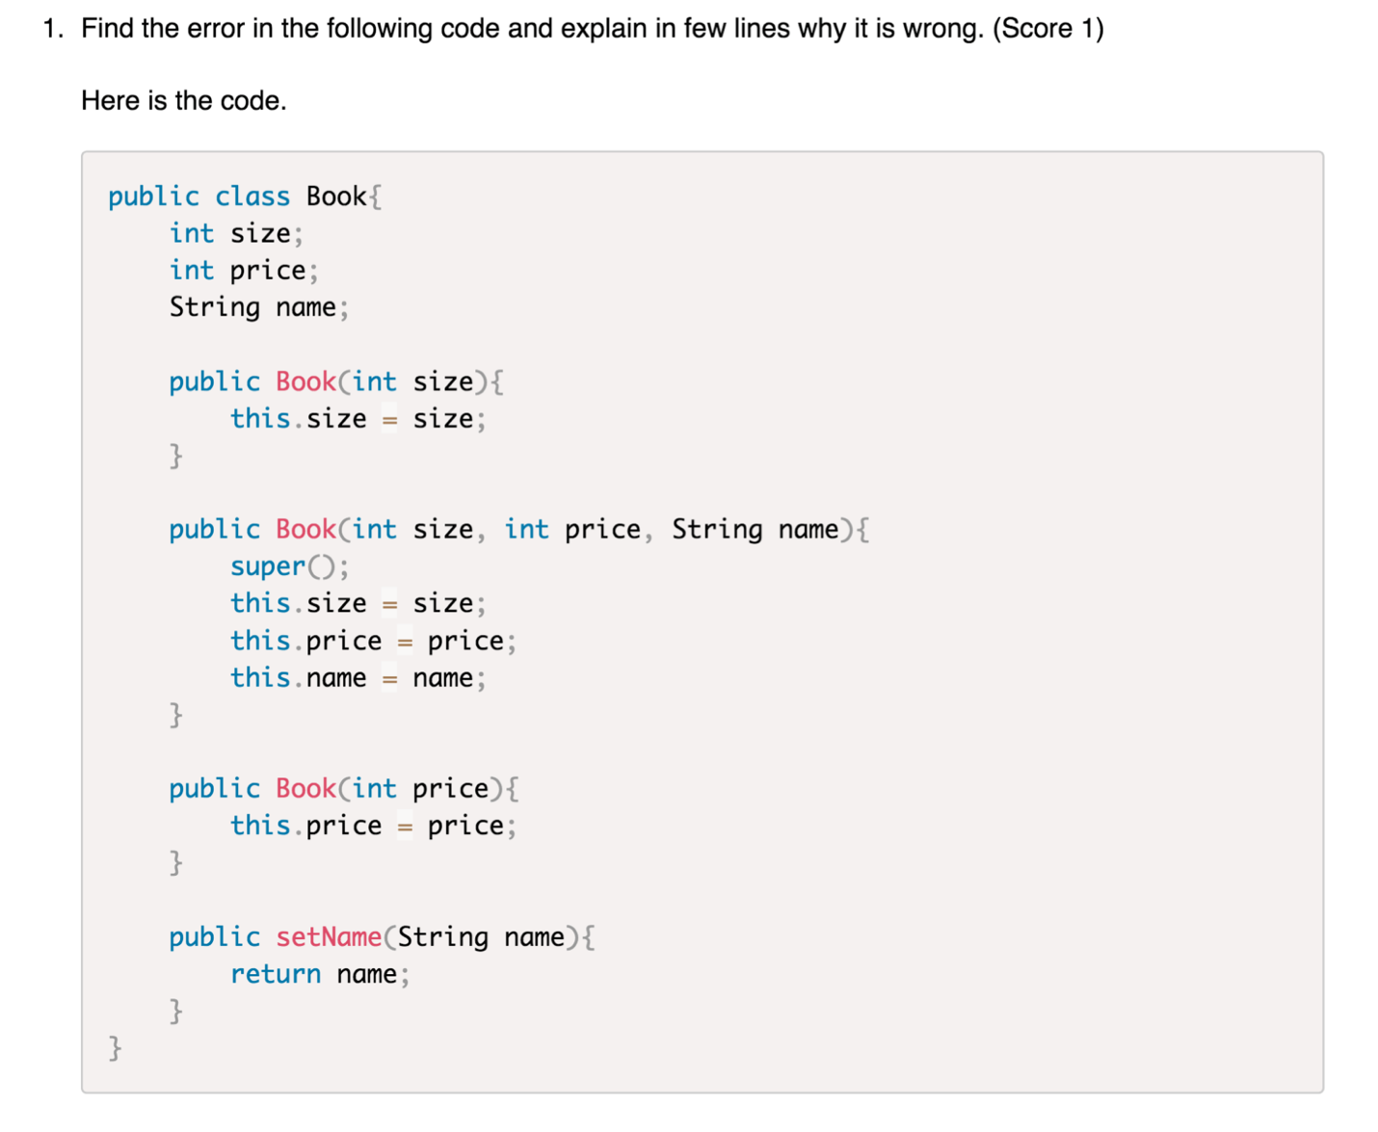

1. *getTime()*  method needs return value *String* instead of *void*

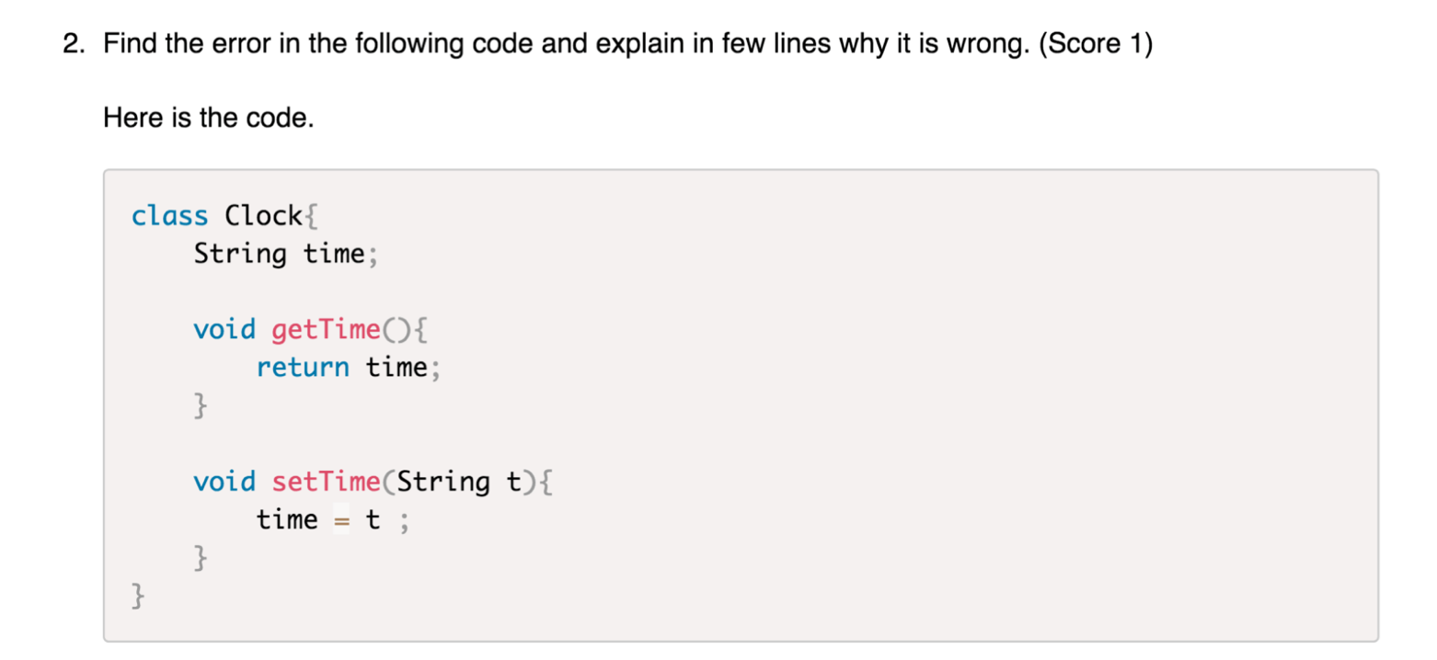

1. (scores 2) 1)What will be the output of the following program?

0

0

10

0

20

30

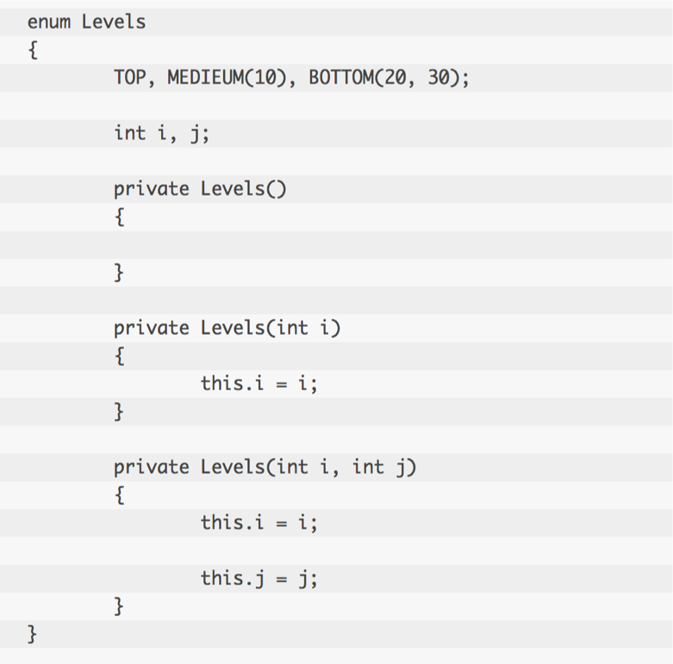 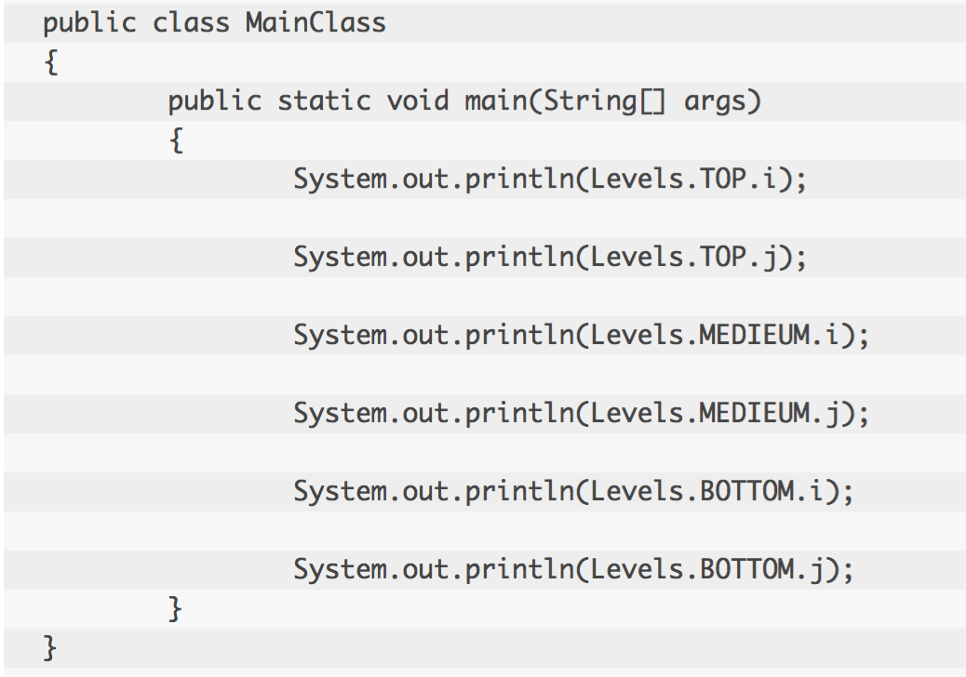

2)Can you find out the error in the below code?

ONE is repeated

